What's MaxRectsBinPack
MaxRects算法是一个二维图像排列算法,在FlashCS6的Sprite导出功能和TexturePacker中均有使用.
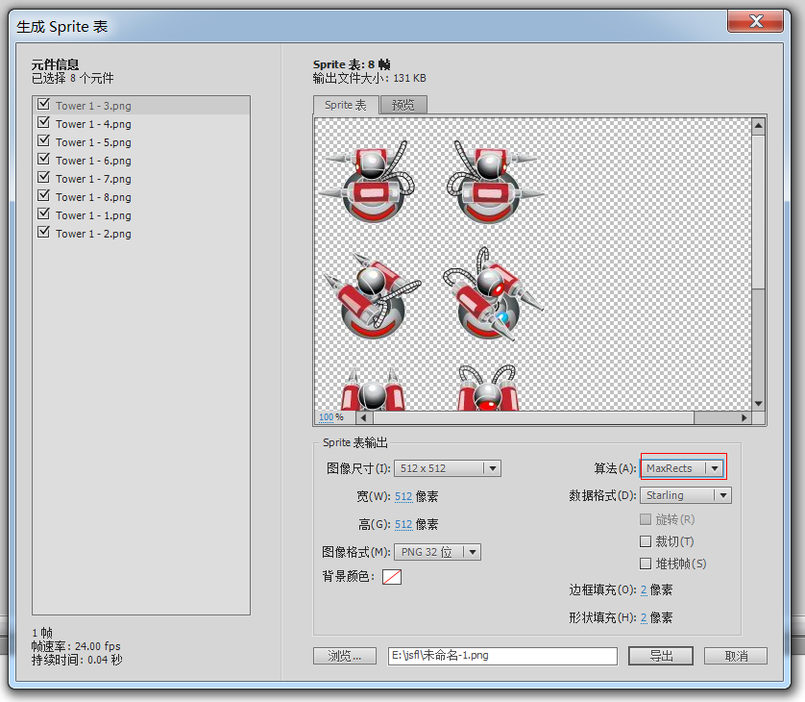
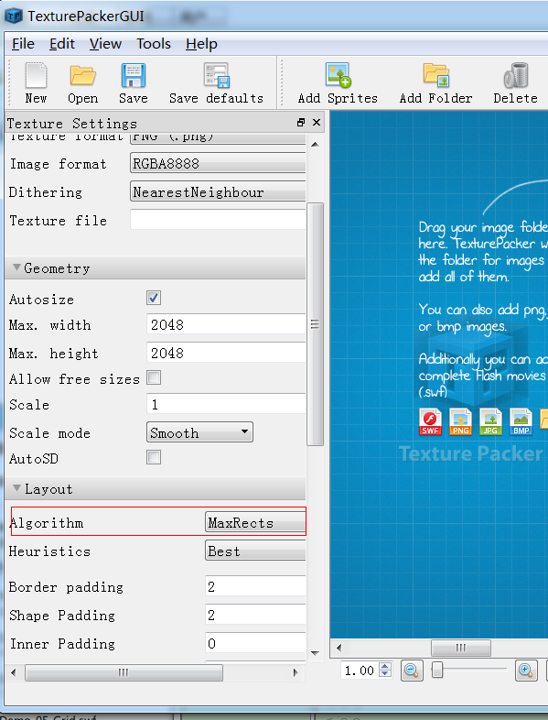

Reference
Based on the Public Domain MaxRectanglesBinPack.cpp source by Jukka Jylänki
https://github.com/juj/RectangleBinPack/
Based on C# port by Sven Magnus
http://unifycommunity.com/wiki/index.php?title=MaxRectanglesBinPack
Ported to ActionScript3 by DUZENGQIANG
This version is also public domain - do whatever you want with it.

Source Code


Download
MaxRectsBinPack.as

How to use
//Create new MaxRectsBinPack instance
var maxRect:MaxRectsBinPack = new MaxRectsBinPack(1024,1024,false);
// insert new rectangle
maxRect.insert(300,200,0);
//There are 5 insert method in FreeRectangleChoiceHeuristic class.
// class FreeRectangleChoiceHeuristic {
// public static const BestShortSideFit:int = 0; ///< -BSSF: Positions the Rectangle against the short side of a free Rectangle into which it fits the best.
// public static const BestLongSideFit:int = 1; ///< -BLSF: Positions the Rectangle against the long side of a free Rectangle into which it fits the best.
// public static const BestAreaFit:int = 2; ///< -BAF: Positions the Rectangle into the smallest free Rectangle into which it fits.
// public static const BottomLeftRule:int = 3; ///< -BL: Does the Tetris placement.
// public static const ContactPointRule:int = 4; ///< -CP: Choosest the placement where the Rectangle touches other Rectangles as much as possible.
//}
usedRectangles: storage of all used rectangles
freeRectangles: storage of all free rectangles
The insert method will return a rectangle. when its width an height are both 0. That means it can not be inserted anymore.
For more information, see a series of blog posts at
http://clb.demon.fi/projects/rectangle-bin-packing
http://clb.demon.fi/projects/more-rectangle-bin-packing
http://clb.demon.fi/projects/even-more-rectangle-bin-packing

http://www.duzengqiang.com/blog/post/971.html

